**Meals on Wheels – FoGo Analysis with Recommendations**

**Version 2.0**

**Date: 2/2021**

**Krishna.Venugopal**

Contents

Section-1: Acknowledgement: 3

Section-2: Today’s food challenge: 3

Section-3: FoGo solution – Building a New System that shines light on what we eat: 3

*Step-1: Nutrient Breakdown used to score each meal* 4

*Step-2: Nutrients used for measuring the 4 Pillars* 6

*Step-3: Determining classification of Scores for 4 Pillars* 9

*Step-4: Conditions used to determine improvement needed in a menu item* 10

Section-4: Application – Applying the New System to Meals on Wheels program 11

*Step-1: Documenting the current Menu items* 11

*Step-2: Scoring the menu items using FoGo – An example run* 13

*Step-3: A side by side view of the base menu and the improved menu* 15

*Step-4: Analyzing the improvements with FoGo’s recommendations* 16

Section-5: Top 20 foods in different food categories based on FOGO ranking: 19

Section-6 Conclusion: 30

## Section-1: Acknowledgement:

I’m greatly thankful to Meals on Wheels for helping me with the details of the menu. Meals on Wheels is an inspiration to me and through this small effort I have hopefully shown my gratitude to the organization that selflessly is serving the needy, impoverished, and the elderly who need our love and support.

## Section-2: Today’s food challenge:

Today’s challenges in food selection are 3 pronged. They are explained below:

1. Measurement of food happens only through calories. So awareness revolves around calories and the idea that the number of calories someone eats dictates whether they are healthy or not.
2. The second problem is with the selections and that the choices of food are not personalized. For example, the classification of someone eating a certain type of food, like a vegetarian or vegan, is overly broad and does not say enough about the actual food itself. Also, food that is good for one person is not necessarily as good for another person.
3. The third problem with today’s method of food selection and awareness connects with the previous problem with the classification of food. Close-loop feedback is not available to show whether the individual’s personalized food choices are making an expected impact on their body, mind, and intellect. Instead, these loops are often forgotten, and in most cases, not even looked at as a follow-up on a person’s health.

## Section-3: FoGo solution – Building a New System that shines light on what we eat:

In order to solve the above problems, we first look at the foundational aspect what is the purpose and nature of food that we consume. The primary purpose of food that we consume can be split into the 4 major categories or Pillars (we use this term “Pillar” quite often in the rest of this disclosure):

1. **Growth** (**G**)– Food is needed for us to grow, especially during the early stage of a lifecycle of a human being
2. **Energy** (**E**) – Food is needed for us to be Nourished so we remain content and satisfied
3. **Immunity** (I) – Food is needed to build our Immunity so we can better fight diseases
4. **Detoxification** (**D**) - The process of energy creation from the food we consume leaves behind waste that needs to be removed timely from our body so they don’t stay longer within our body and cause harm. An important aspect of food that we eat needs to be to remove this waste from our body. In addition to this key activity, food also has to act as an anti-inflammation and anti-oxidation agent to counter the effects of the toxins that are created in the body.

The above 4 first principles of food are primarily used as the foundation for building a new system. This is contrasted with the current system which is one dimensional as mentioned in the last section and focuses only on energy or calories and thereby portion size that is associated with calorie count. With this new measurement in place, we can spread awareness about all the 4 nature of food that is consumed and emphasize the need to focus on all the 4 without compromising on any one of these pillars.

## Step-1: Nutrient Breakdown used to score each meal

For each of the above food item, there are 91 different sub-constituents based on a specific food size or portion. Given below are the sub-constituents that are in the dataset with the identifiers from D to CS on their titles that we will use in the next section to build the algorithms:

For meals that are not directly available, we have broken them down to individual items.

|  |  |  |  |  |  |  |  |  |  |  |  |  |  |  |  |  |  |  |  |  |  |  |  |  |
| --- | --- | --- | --- | --- | --- | --- | --- | --- | --- | --- | --- | --- | --- | --- | --- | --- | --- | --- | --- | --- | --- | --- | --- | --- |
| **D**  **Calories** | | **E**  **Fat (g)** | | | **F**  **Protein (g)** | **G**  **Carbohydrate (g)** | | | **H**  **Sugars (g)** | | | **I**  **Fiber (g)** | | **J**  **Cholesterol (mg)** | | **K**  **Saturated Fats (g)** | | | **L**  **Calcium (mg)** | | | **M**  **Iron Fe (mg)** | | |
| **N**  **Potassium, K (mg)** | | | **O**  **Magnesium (mg)** | | | | **P**  **Vitamin A, IU (IU)** | | | **Q**  **Vitamin A, RAE (mcg)** | | | **R**  **Vitamin C (mg)** | | | | **S**  **Vitamin B-12 (mcg)** | | | **T**  **Vitamin D (mg)** | | |
| **U**  **Vitamin E (Alpha-Tocopherol) (mg)** | | | **V**  **Added Sugar (g)** | | | | **W**  **Net-Carbs (g)** | | | **X**  **Water (g)** | | | **Y**  **Omega 3s (mg)** | | | | **Z**  **Omega 6s (mg)** | | | **AA**  **PRAL score** | | | **(g)** | | |
| **AB**  **Trans Fatty Acids (g)** | | | **AC**  **Soluble Fiber (g)** | | | | **AD**  **Insoluble Fiber (g)** | | | **AE**  **Sucrose (g)** | | | | **AF**  **Glucose (Dextrose) (g)** | | | **AG**  **Fructose (g)** | | | **AH**  **Lactose (g)** | | | **(g)** | | | **Galactose (g)** | **Starch (g)** |

|  |  |  |  |  |  |  |
| --- | --- | --- | --- | --- | --- | --- |
| **AI**  **Maltose (g)** | **AJ**  **Galactose (g)** | **AK**  **Starch (g)** | **AL**  **Total sugar alcohols (g)** | **AM**  **Phosphorus, P (mg)** | **AN**  **Sodium (mg)** | **AO**  **Zinc, Zn (mg)** |

|  |  |  |  |  |  |  |  |
| --- | --- | --- | --- | --- | --- | --- | --- |
| **AP**  **Copper, Cu (mg)** | **AQ**  **Manganese (mg)** | **AR**  **Selenium, Se (mcg)** | **AS**  **Fluoride, F (mcg)** | **AT**  **Molybdenum (mcg)** | **AU**  **Chlorine (mg)** | **AV**  **Thiamin (B1) (mg)** | **mg)** |

|  |  |  |  |  |  |  |
| --- | --- | --- | --- | --- | --- | --- |
| **AW**  **Riboflavin (B2) (mg)** | **AX**  **Niacin (B3) (mg)** | **AY**  **Pantothenic acid (B5) (mg)** | **AZ**  **Vitamin B6 (mg)** | **BA**  **Biotin (B7) (mg)** | **BB**  **Folate (B9) (mg)** | **BC**  **Folic acid (mcg)** |

|  |  |  |  |  |  |  |
| --- | --- | --- | --- | --- | --- | --- |
| **BD**  **Food Folate (mcg)** | **BE**  **Folate DFE (mcg)** | **BF**  **Choline (mg)** | **BG**  **Betaine (mg)** | **BH**  **Retinol (mcg)** | **BI**  **Carotene, beta (mcg)** | **BJ**  **Carotene, alpha (mcg)** |

|  |  |  |  |  |  |  |
| --- | --- | --- | --- | --- | --- | --- |
| **BK**  **Lycopene (mcg)** | **BL**  **Lutein + Zeaxanthin (mcg)** | **BM**  **Vitamin D2 (ergocalciferol) (mcg)** | **BN**  **Vitamin D3 (cholecalciferol) (mcg)** | **BO**  **Vitamin D (IU) (IU)** | **BP**  **Vitamin K (mcg)** | **BQ**  **Dihydrophylloquinone (mcg)** |

|  |  |  |  |  |  |  |
| --- | --- | --- | --- | --- | --- | --- |
| **BR**  **Menaquinone-4 (mcg)** | **BS**  **Fatty acids, total monounsaturated (mg)** | **BT**  **Fatty acids, total polyunsaturated (mg)** | **BU**  **18:3 n-3 c,c,c (ALA) (mg)** | **BV**  **20:5 n-3 (EPA) (mg)** | **BW**  **22:5 n-3 (DPA) (mg)** | **BX**  **22:6 n-3 (DHA) (mg)** |

|  |  |  |  |  |  |  |
| --- | --- | --- | --- | --- | --- | --- |
| **BY**  **Tryptophan (mg)** | **BZ**  **Threonine (mg)** | **CA**  **Isoleucine (mg)** | **CB**  **Leucine (mg)** | **CC**  **Lysine (mg)** | **CD**  **Methionine (mg)** | **CE**  **Cystine (mg)** |

|  |  |  |  |  |  |  |
| --- | --- | --- | --- | --- | --- | --- |
| **CF**  **Phenylalanine (mg)** | **CG**  **Tyrosine (mg)** | **CH**  **Valine (mg)** | **CI**  **Arginine (mg)** | **CJ**  **Histidine (mg)** | **CK**  **Alanine (mg)** | **CL**  **Aspartic acid (mg)** |

|  |  |  |  |  |  |  |
| --- | --- | --- | --- | --- | --- | --- |
| **CM**  **Glutamic acid (mg)** | **CN**  **Glycine (mg)** | **CO**  **Proline (mg)** | **CP**  **Serine (mg)** | **CQ**  **Hydroxyproline (mg)** | **CR**  **Alcohol (g)** | **CS**  **Caffeine (mg)** |

## Step-2: Nutrients used for measuring the 4 Pillars

Given below are each of the nutrients that we have used to measure the Scores for Growth, Energy, Immunity, and Detoxification. The below nutrients are fed into the algorithms that then provide the score for each food item.

**Growth**

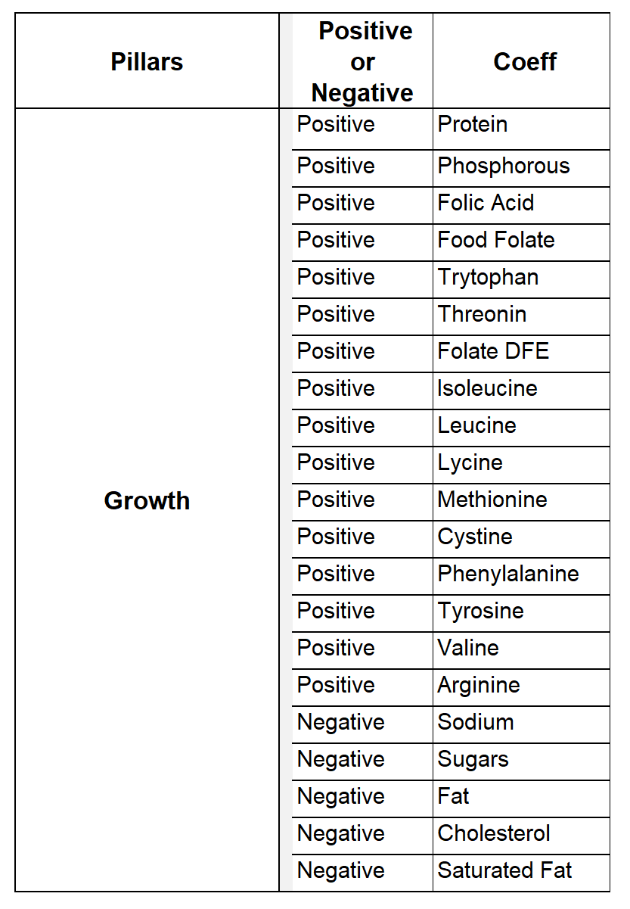

**Energy**

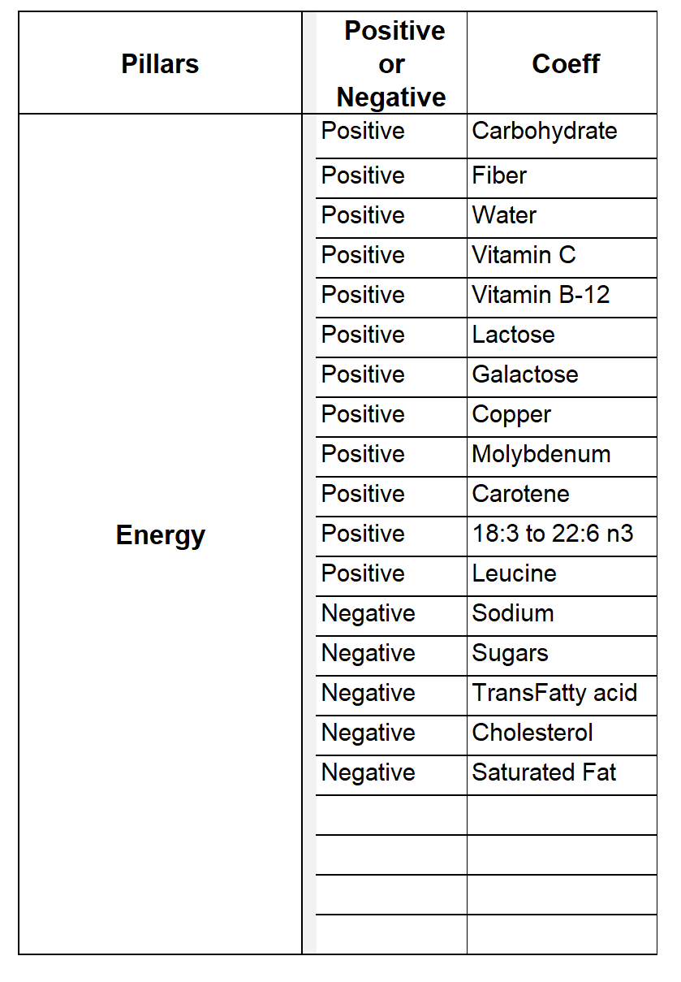

**Immunity**

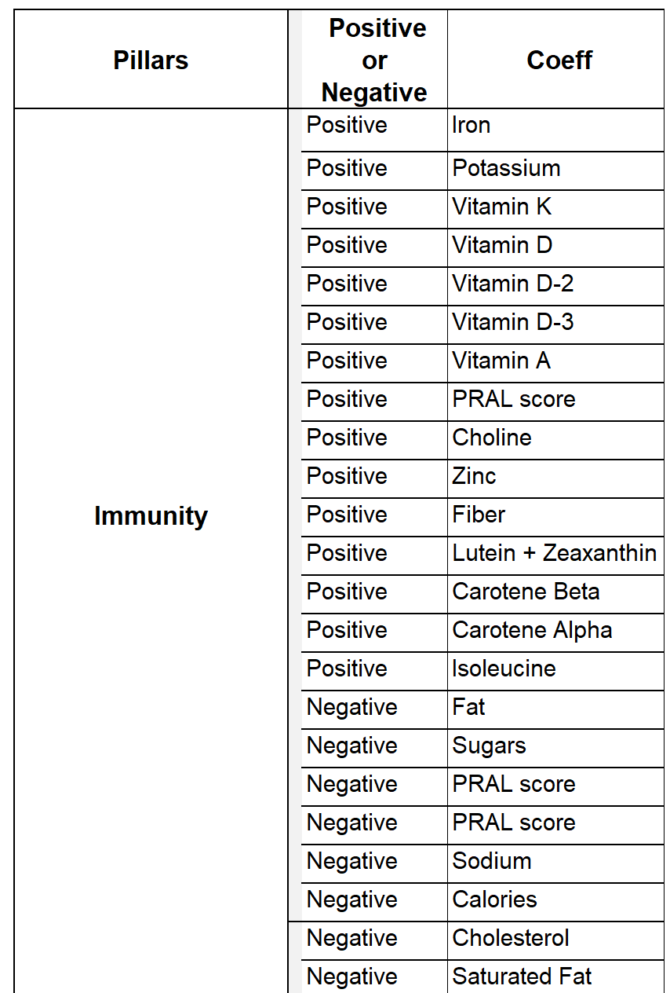

**Detoxification**

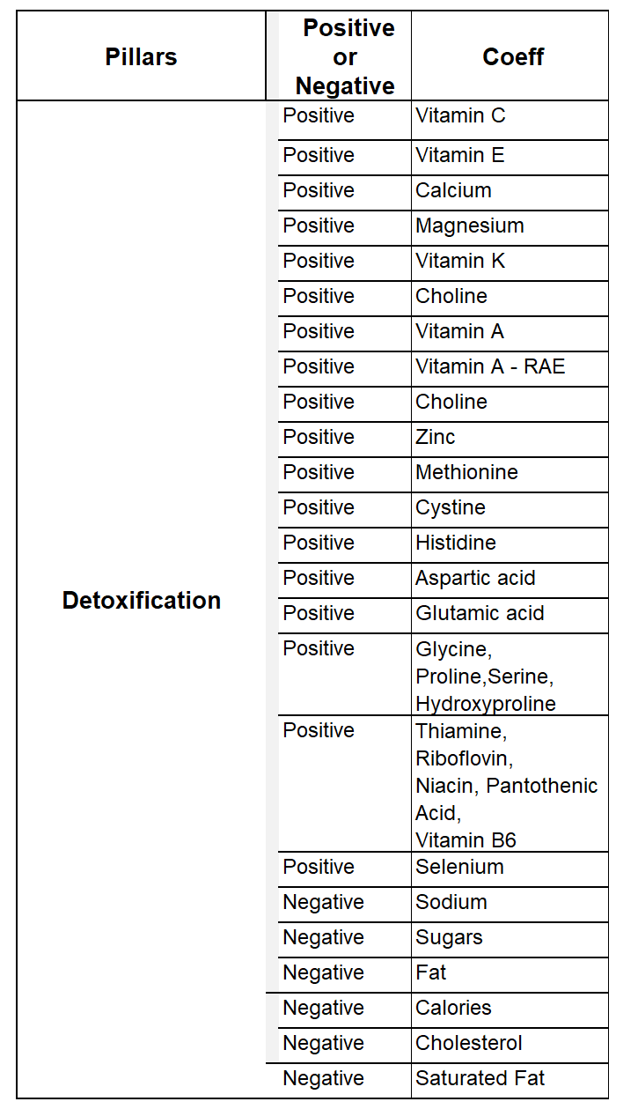

## Step-3: Determining classification of Scores for 4 Pillars

The scores for each Pillar is classified into 4 categories – Excellent, Good, Ok, and Bad. Given below are the score ranges that determines the category for each Pillar

Growth – Excellent is > 75, Good is > 50, Ok is > 25, Improvement needed is < 25

Energy – Excellent is > 75, Good is > 50, Ok is > 25, Improvement needed is < 25

Immunity – Excellent is > 50, Good is > 30, Ok is > 10, Improvement needed is < 10

Detoxification – Excellent is > 50, Good is > 30, Ok is > 10, Improvement needed is < 10

Excellent is represented by  symbol

Good is represented by  symbol

Ok is represented by  symbol

Need improvement is  symbol

## Step-4: Conditions used to determine improvement needed in a menu item

First consideration was the audience to which Meals on Wheels caters to. Keeping in mind that the audience is elderly, the first objective of the software is to hit 4 bars on both Immunity and Detox. Hitting 4 bars, as mentioned earlier, will be to at least have a score of 45 for both Immunity and Detox.

The second objective of the software is to hit at least 3 bars for Energy. Hitting 3 bars for Energy means getting a score of over 50 for Energy.

The final objective of the software is to hit at least 2 bars for Growth. Again taking into account the audience age group, we made the assumption that excess protein consumption is not required. Thus a score of over 25 for Growth is set as objective.

The main constraint applied is to first preserve the main dish as is and only change as the final resort. The FoGo algorithm applies logic based on the nutrient breakdown table towards increasing immunity, detoxification, and energy

## Section-4: Application – Applying the New System to Meals on Wheels program

## Step-1: Documenting the current Menu items

**December 7 thru December 11, 2020**

**Monday:**

1. Savory Sausage & Grits

Broccoli

Spiced Applesauce

1. Tuna fish Casserole

Mixed Vegetables

Congo Square

**Tuesday:**

1. Salisbury steak w/Mush. Gravy

Cheesy Penne

Green Beans

1. Pork Chop over Rice

Braised Cabbage

Smashed Sweet Potatoes

**Wednesday:**

1. Stuffed Bell Pepper

Italian Vegetables

Brownie

1. Tomatillo Chicken over Rice

Black Bean Soup

Sweet Corn

**Thursday:**

1. Chicken Noodle Casserole

Zucchini

Chocolate Pudding

1. Chicken & Sausage Jambalaya

Mustard Greens

Spiced Applesauce

**December 14th to 18th, 2020**

**Monday:**

1. Beefy Mac & Cheese

Spinach

Brownie

1. Chicken Alfredo

Yellow Squash

Oatmeal Bars

**Tuesday:**

1. Lasagna

Italian Vegetables

Apple Pie Squares

1. Lentil Soup

Focaccia

Broccoli

**Wednesday:**

1. Tomatillo Chicken Enchiladas

Refried Beans

Rice

1. Lentil Soup

**Thursday:**

1. Southwestern Scramble

Potatoes O’Brien

Peas & Carrots

1. Chili

**Friday:**

1. Homemade Chili

Cornbread

Mixed Vegetables

1. Open Face Turkey Burger

Wedge Fries

Peas & Carrots

**December 21 thru 25, 2020**

**Monday:**

1. Chicken Parmesan over Noodles

Italian Vegetables

Blueberry Crisp0

1. Country Fried Steak

Mac & Cheese

Green Beans

**Tuesday:**

1. Meatloaf

Mac & Cheese

Broccoli

1. Hoppin’ Johns

Mustard Greens

Cornbread

**Wednesday:**

1. Pork Loin over Stuffing

Smashed Yams

Green Bean Casserole

1. Bratwurst over Cabbage

Roasted Potatoes

Broccoli Normandy

## Step-2: Scoring the menu items using FoGo – An example run

The first item that we scored is Dec 7th Monday’s menu item.

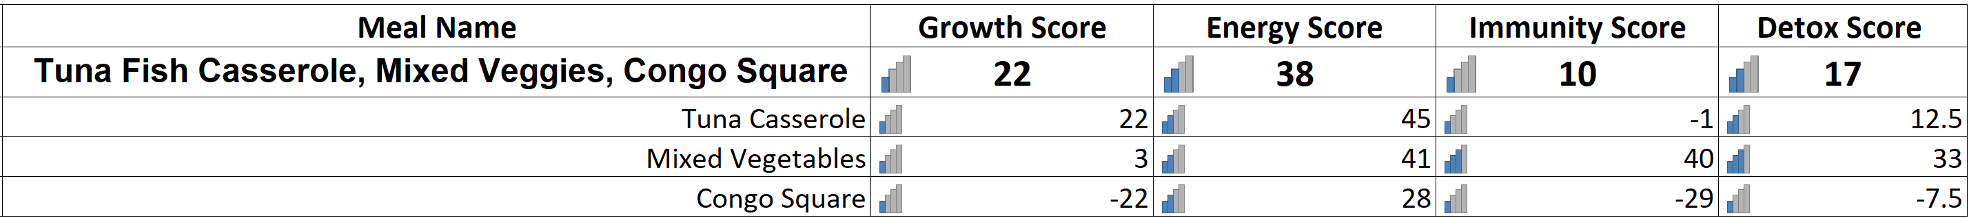

Following the logic steps as explained in Step-4 of the previous section, FoGo tool predicting the below regressive improvements for this particular menu item:

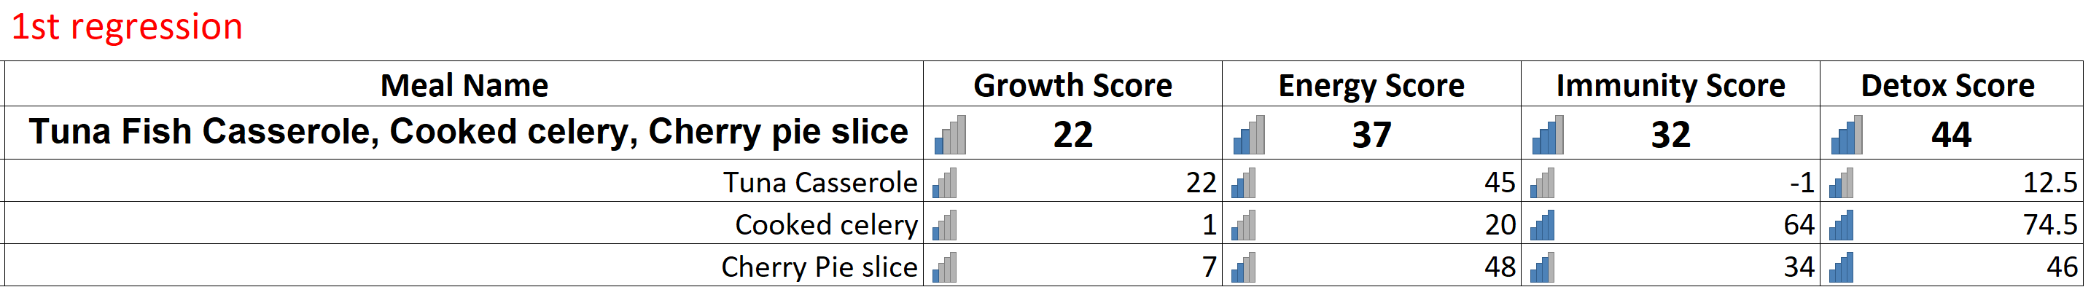

As shown above, we have suggested to replace Congo Square and Mixed Vegetables with Cherry Pie slice and Cooked celery respectively. Since both Cooked celery and Cherry pie slice have a better overall pillar scores, their substitution into the menu improved the Energy score to 37 from 26 and also considerably increases the Immunity and Detox pillar scores to well above the GOOD category.

In the next step, we add a few more sides to further improve Growth, Immunity, and Detox. The sides that we have suggested to add are 1 tbsp of Olive oil and Warm papaya leaf tea before the meals. In addition, we have also added 1 serving of flax seeds as another side. With these additions into the menu, given below is the overall menu score:

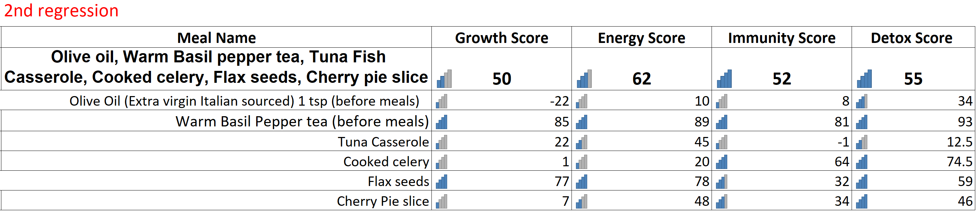

As shown in the above table, the overall scores of all the pillars have now improved from where we initially started. While the Growth score has improved to OK category, Energy score has improved and is closer to Good category, Immunity has improved to the Good category, and Detox has improved to Excellent category.

## Step-3: A side by side view of the base menu and the improved menu

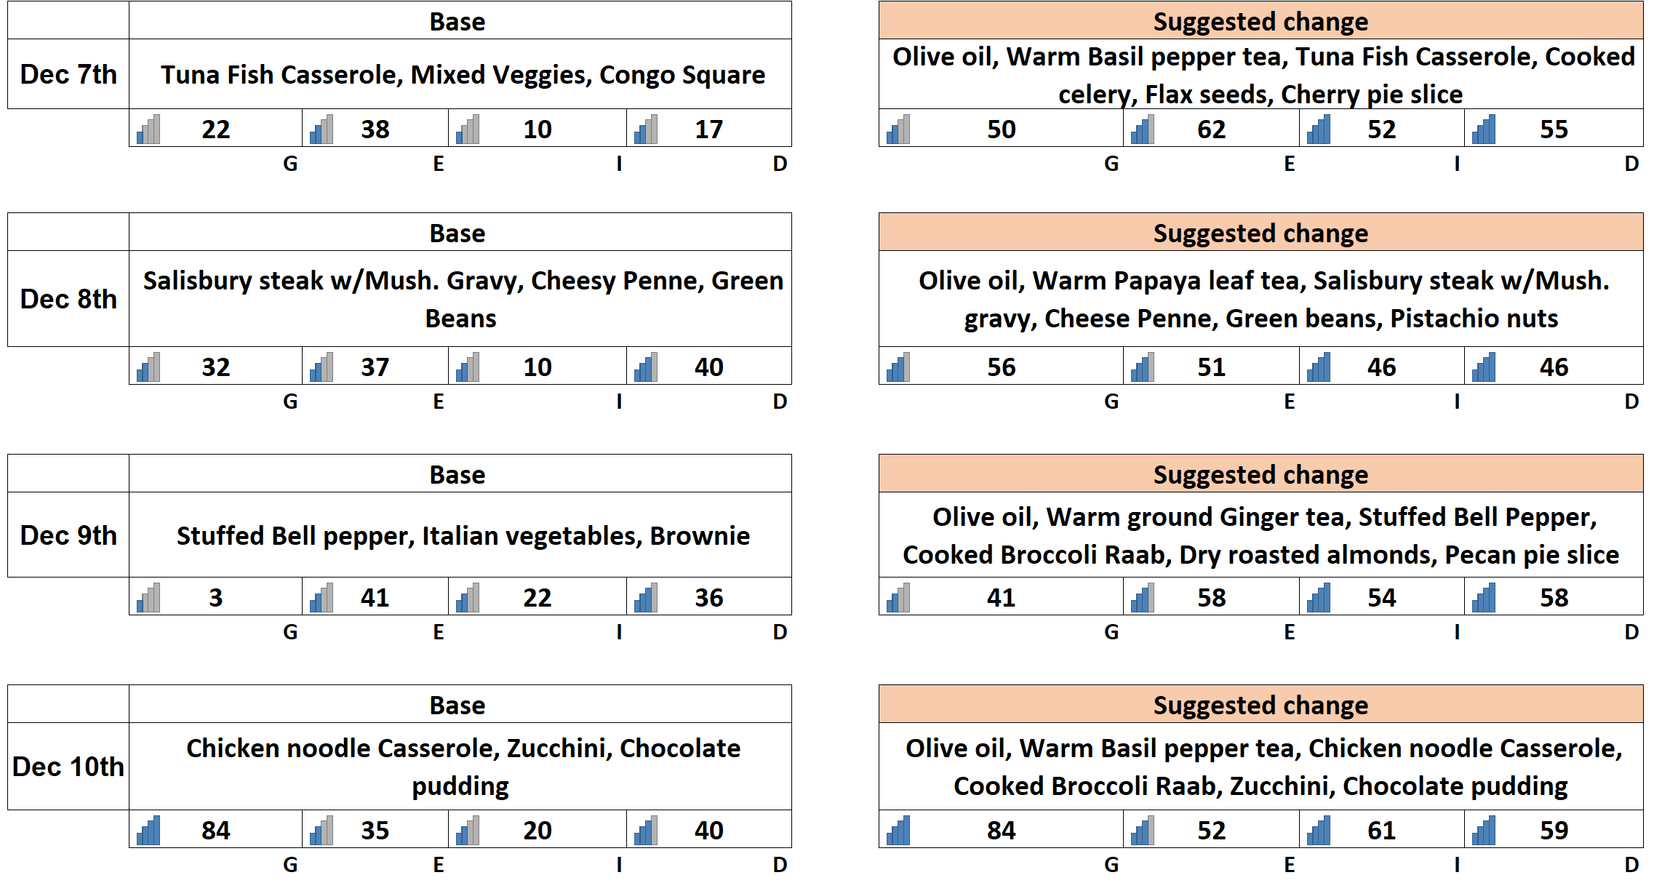

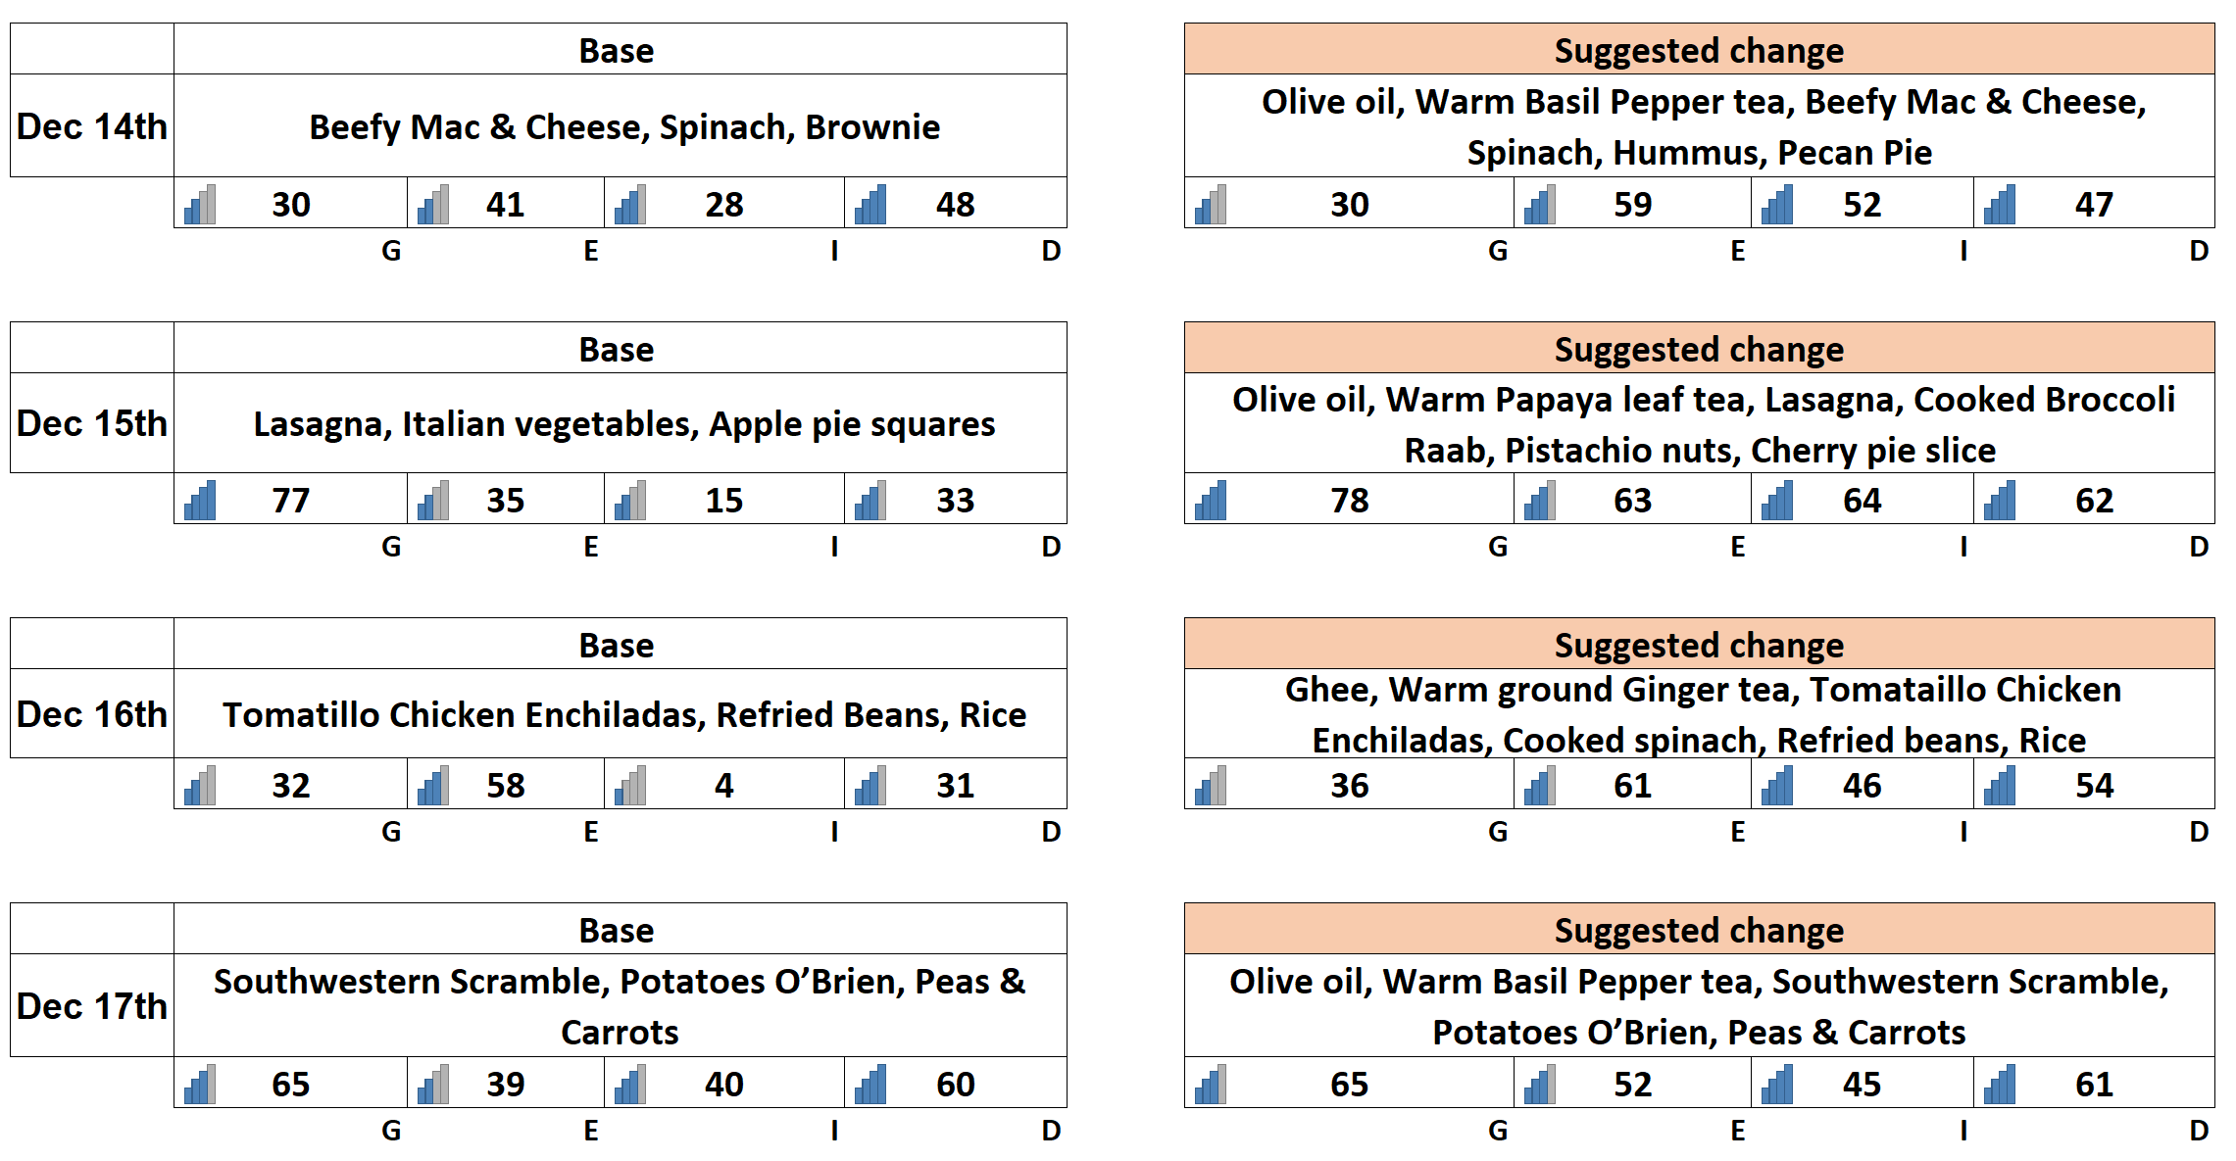

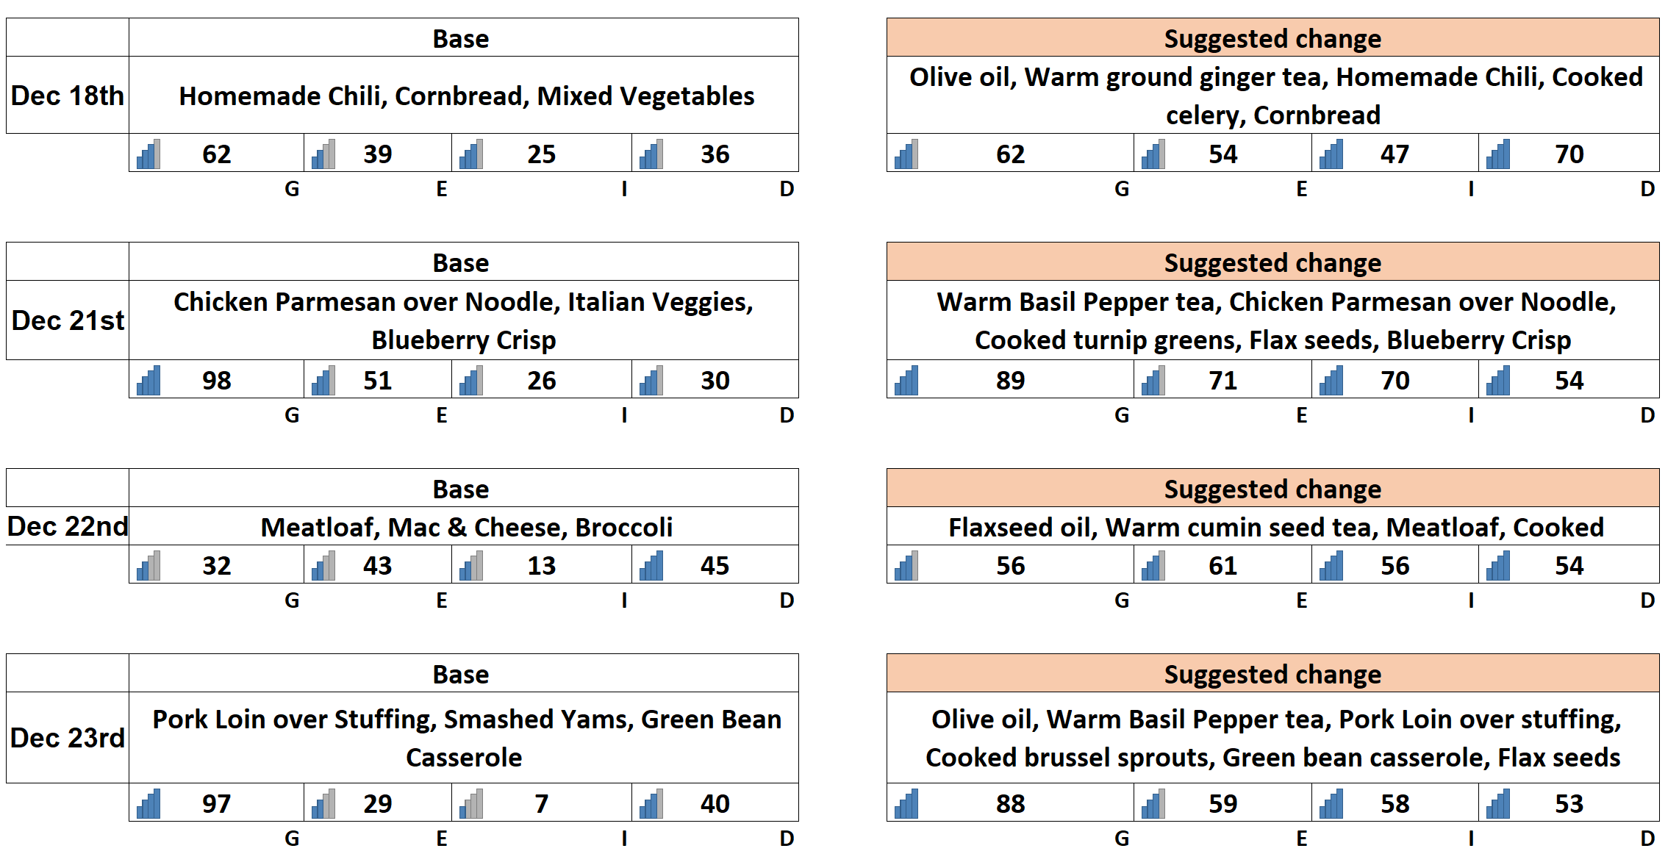

## Step-4: Analyzing the improvements with FoGo’s recommendations

The first item that we scored is Dec 7th Monday’s menu item.

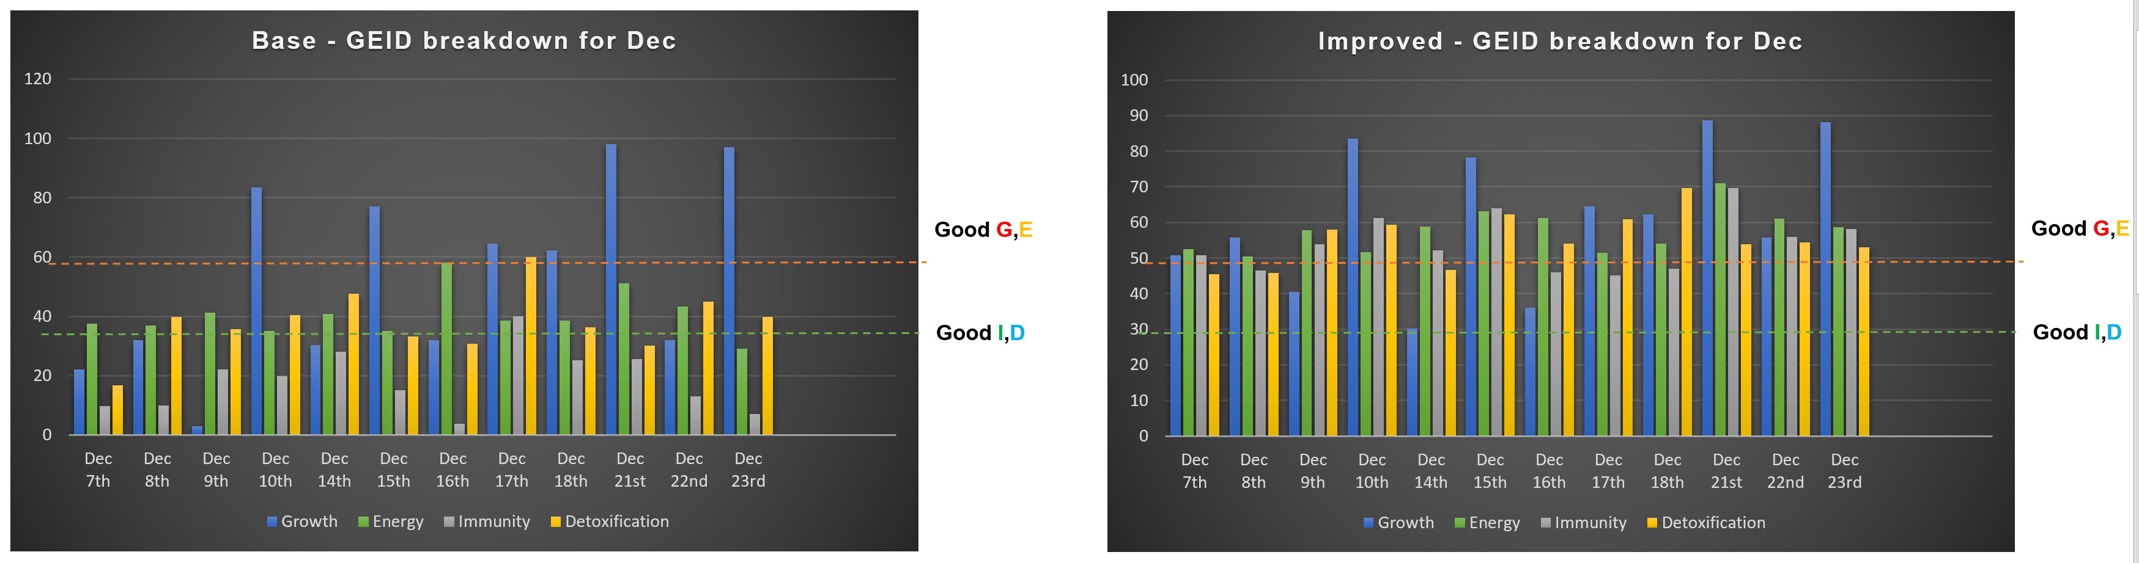

Above is side by side view of the 4 pillars over the days of the review cycle. As is shown above, all the 4 pillars have improved significantly and hit the required goals that were set at the beginning of this exercise.

Given below are the comparative view of each of the pillars over the course of the review cycle and how they have improved during that time.

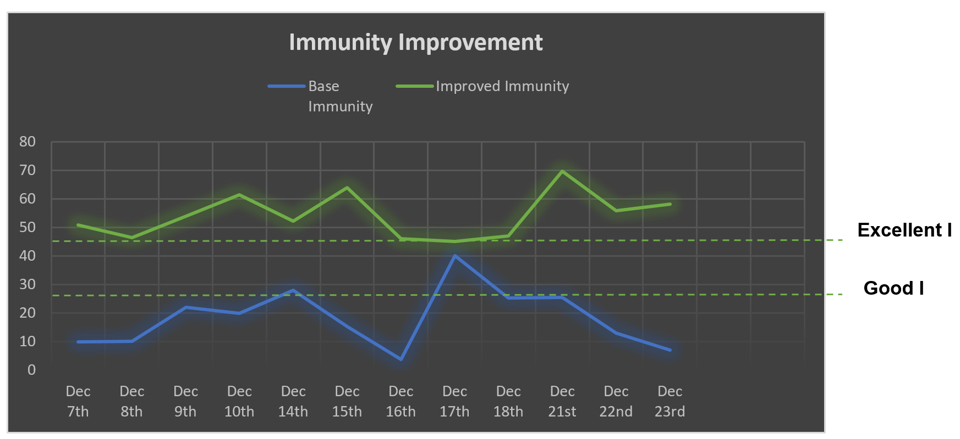

Immunity has improved on all days to be over a score of 45 and consistently stays in the range of 45-70. The base menu stayed in the range of -5 to 40. Overall this is a 197% improvement over the review cycle.

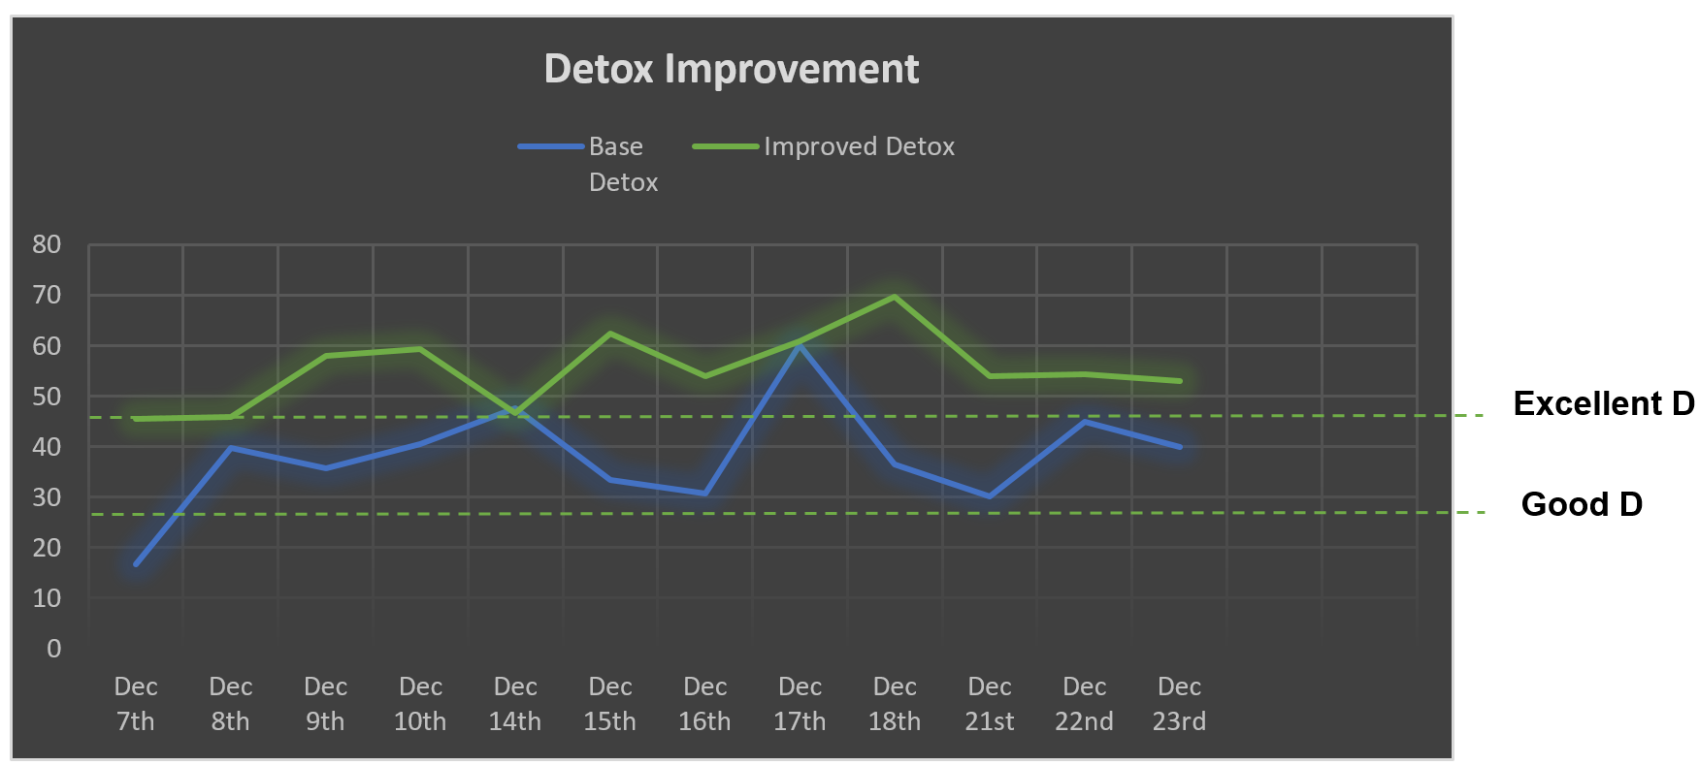

Detox has improved on all days to be over a score of 45 and consistently stays in the range of 45-70. The base menu stayed in the range of 15 to 60. Overall this is a 48% improvement over the review cycle.

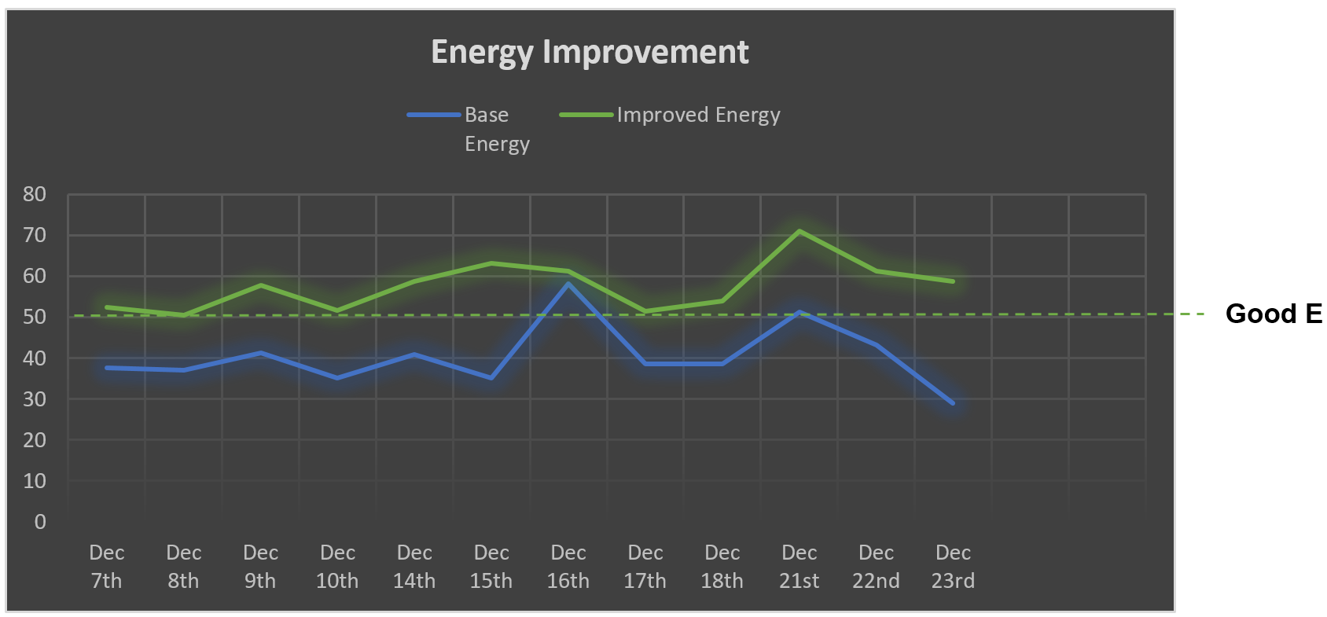

Energy has improved on all days to be over a score of 50 and consistently stays in the range of 50-70. The base menu stayed in the range of 35 to 55. Overall this is a 44% improvement over the review cycle.

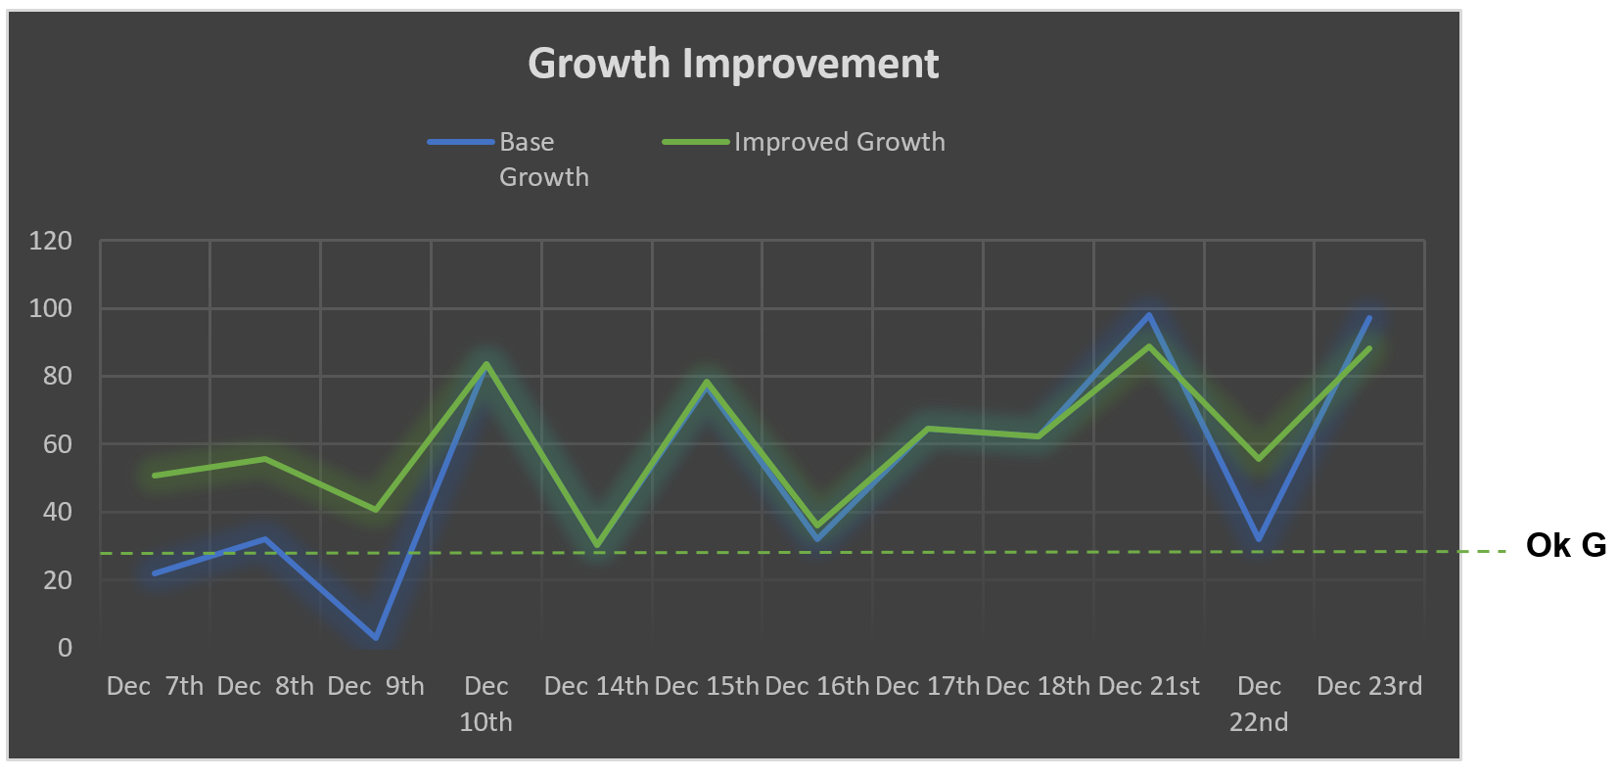

Growth has improved on all days to be over a score of 25 and consistently stays in the range of 25-95. The base menu stayed in the range of 0 to 95. Overall this is a 16% improvement over the review cycle.

## Section-5: Top 20 foods in different food categories based on FOGO ranking:

I’m greatly thankful to Meals on Wheels organization to giving me access and discussing with me in person about your specific needs and the details of the report contained in the previous sections. As an outcome, I gathered that the Meals on Wheels organization’s operation in charge and the chef both would like to have a list of food items in different food categories that are ranked by using the FOGO algorithm that takes into account all the dimensions of the food nutrients that are encapsulated in the 4 defining pillars – Growth (G), Energy (E), Immunity (I), and Detoxification (D).

In this section we will provide at least 20 items in the different food categories prioritized using at least one of the 4 FOGO Pillars. The fundamental idea that FOGO highlights is that a particular main order food item scoring high on one pillar might actually have a low score on other pillars. So in order to bring up the score of the other pillars in that meal, side orders that have a higher score on those pillars are added to bring up the total score of the meal in all the 4 pillars.

With the above fundamental idea in place, please refer to the logic that we have applied in order to rank the food items in the different food categories that we considered. The pillar that is used as the prioritizing descriptor is highlighted in green.

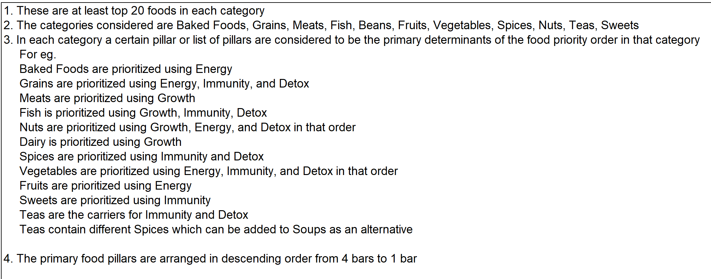

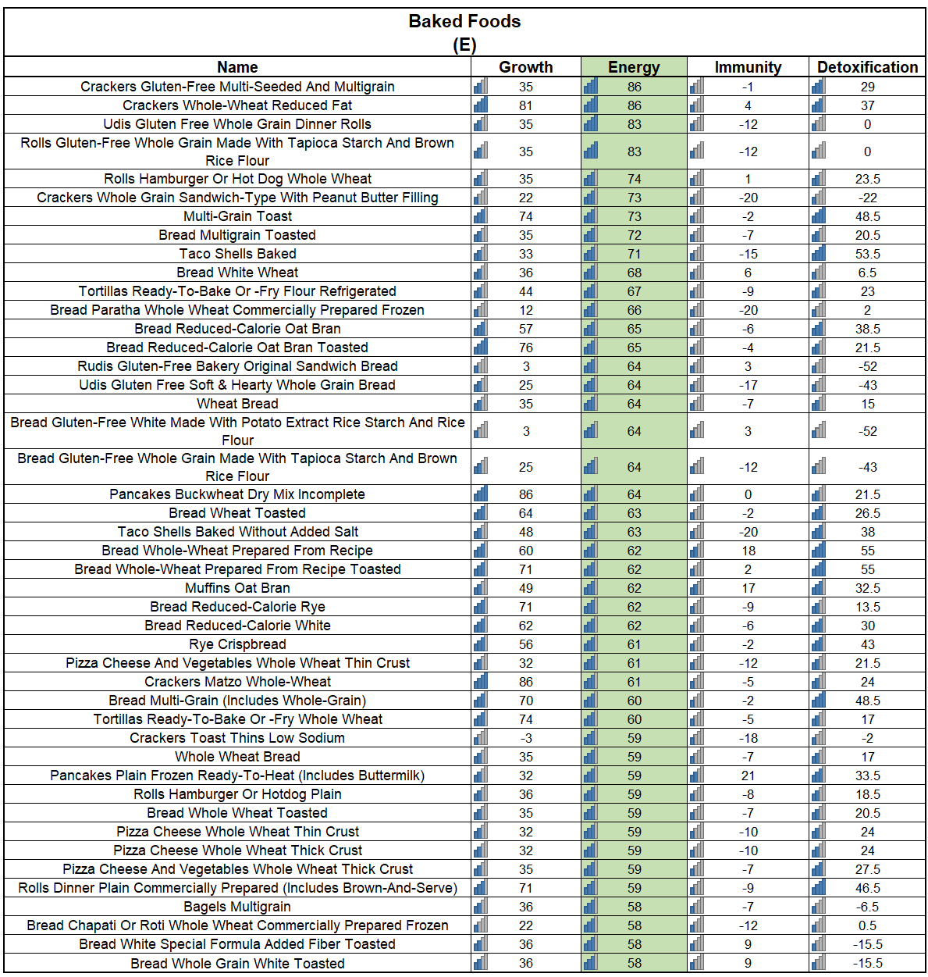

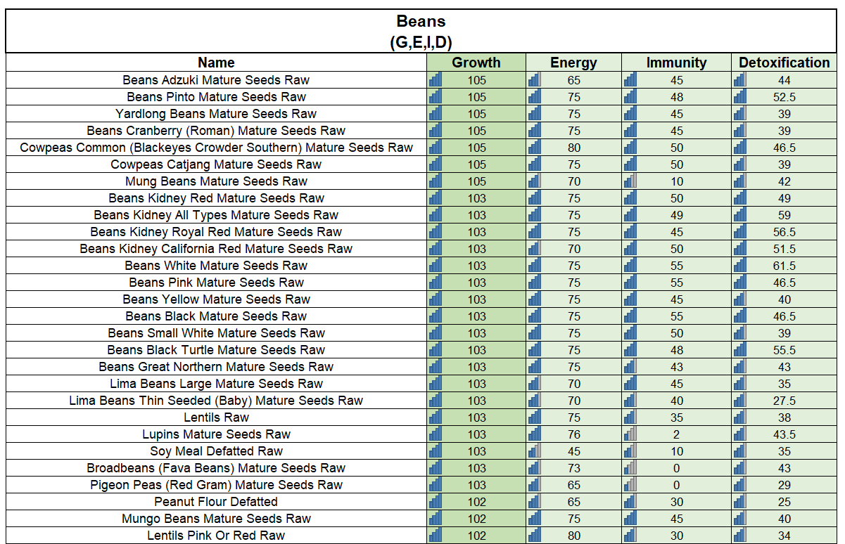

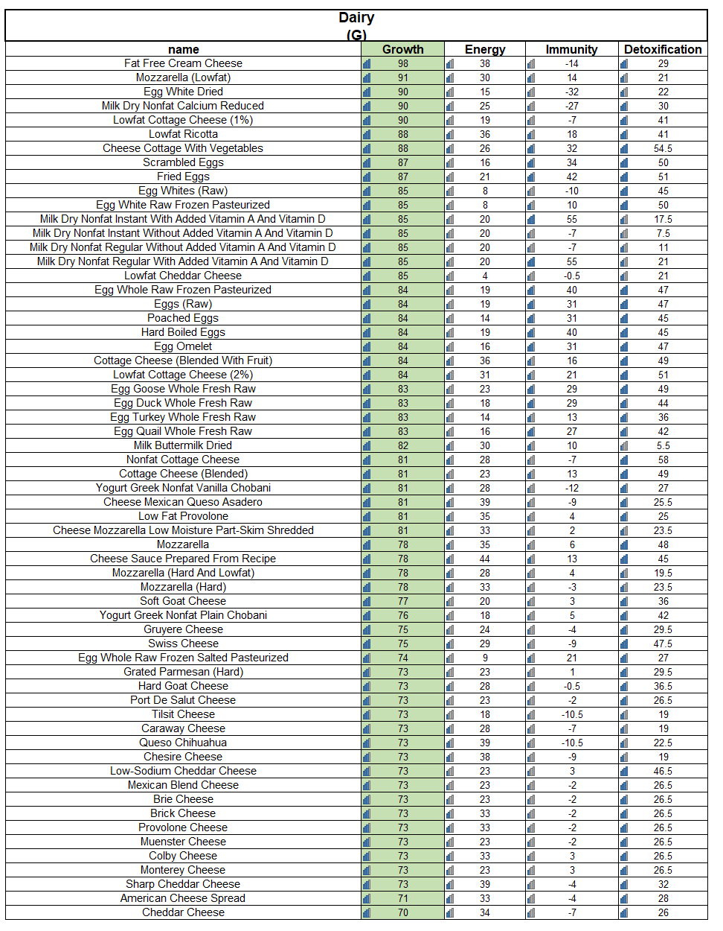

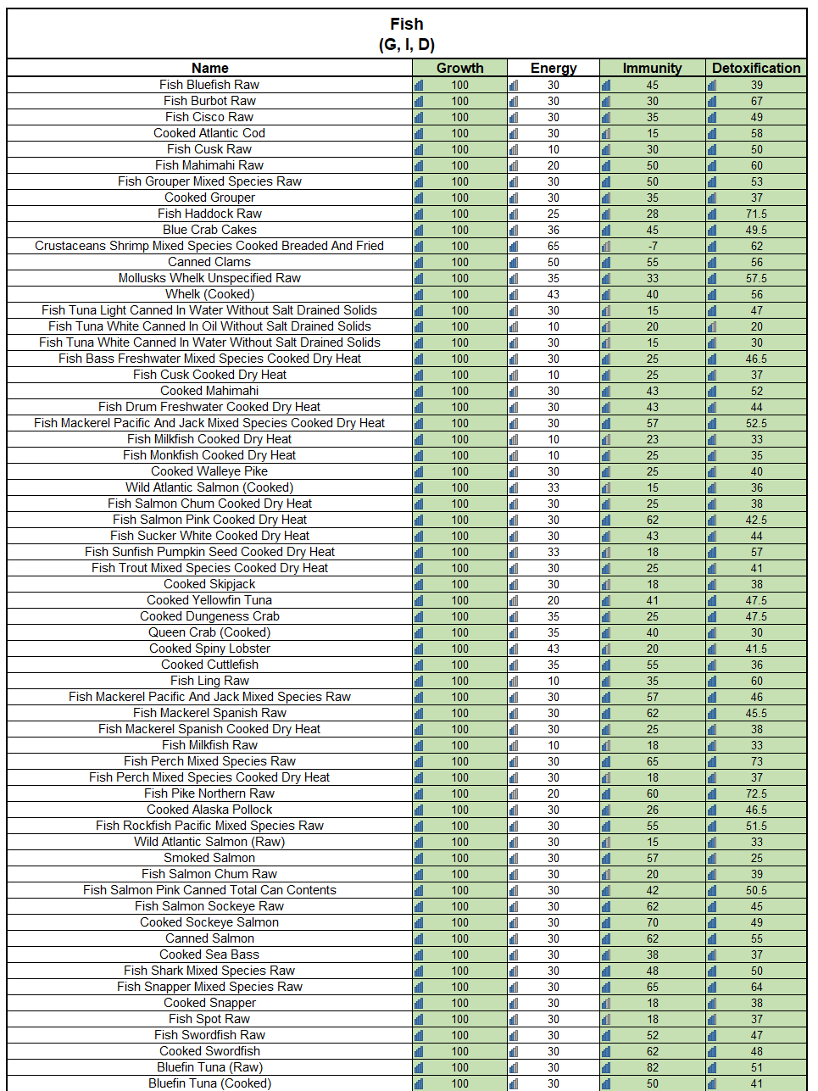

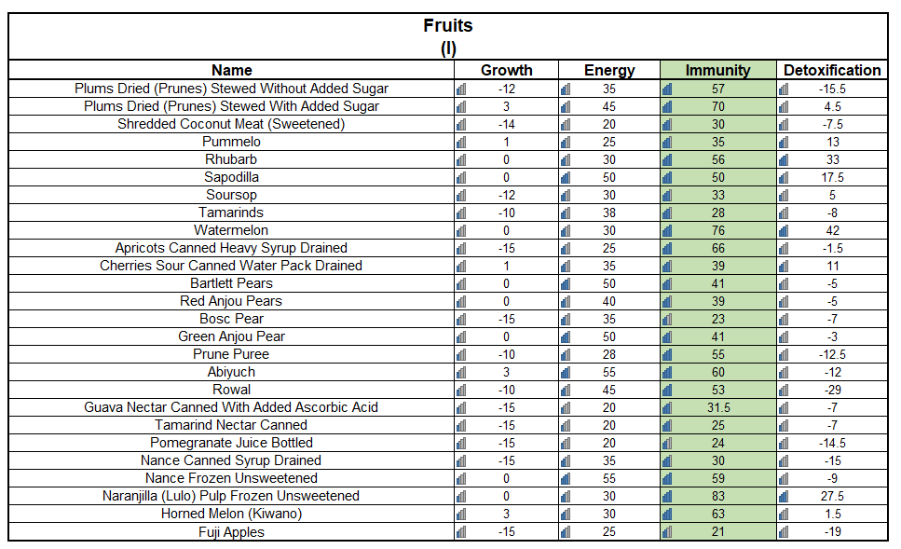

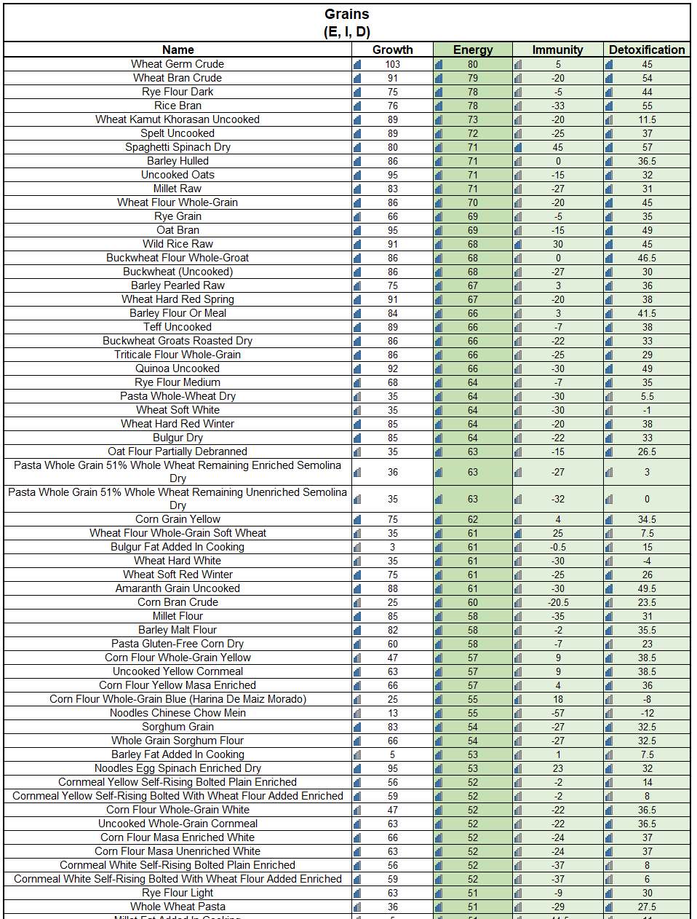

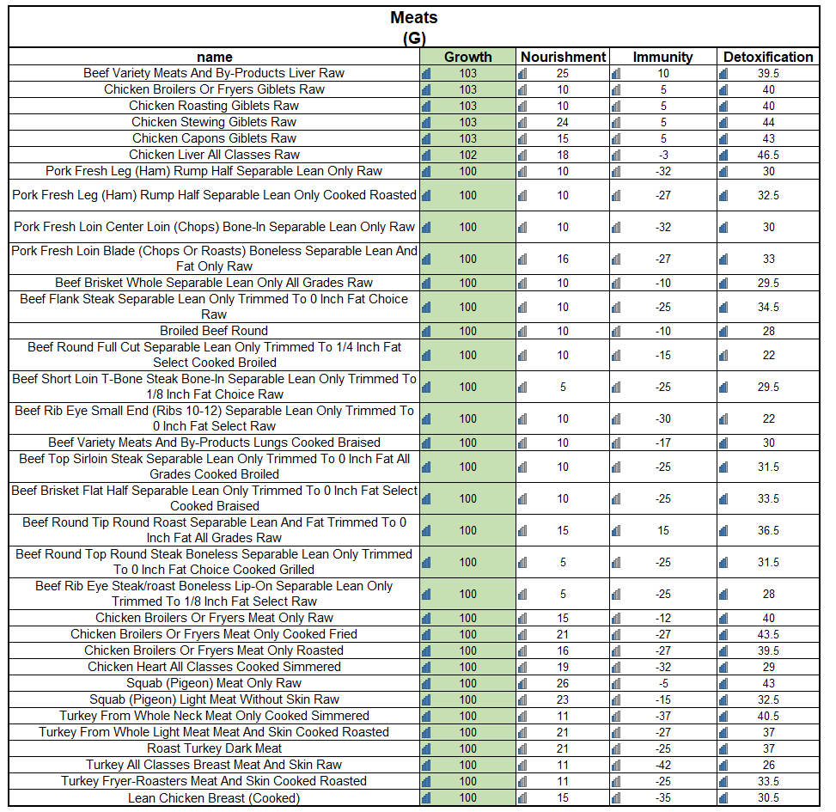

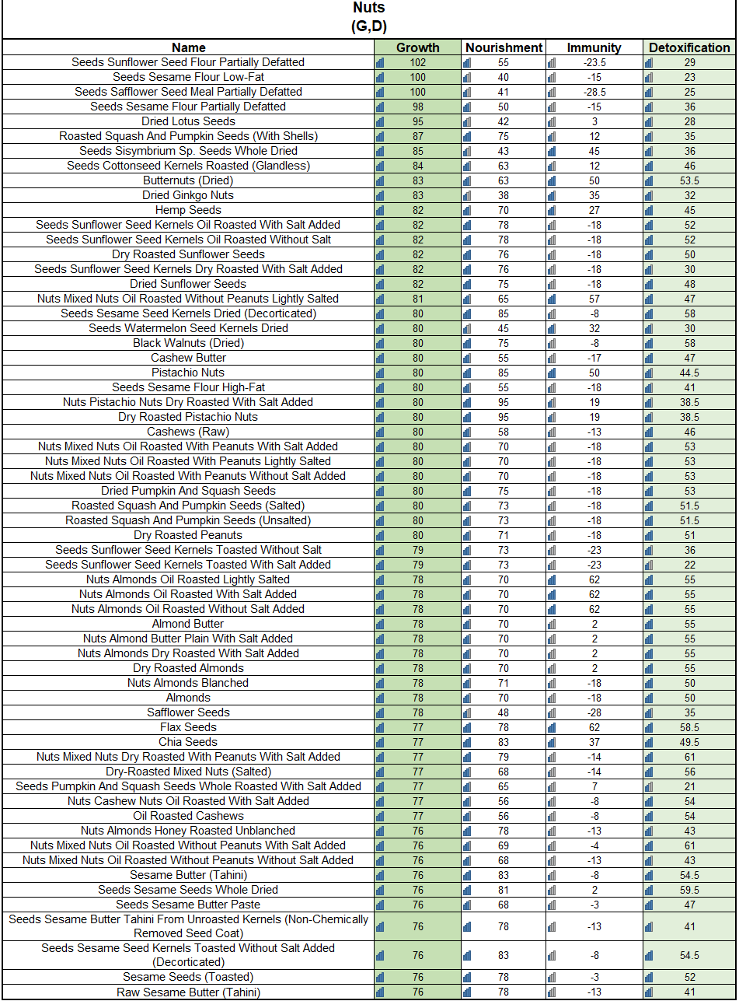

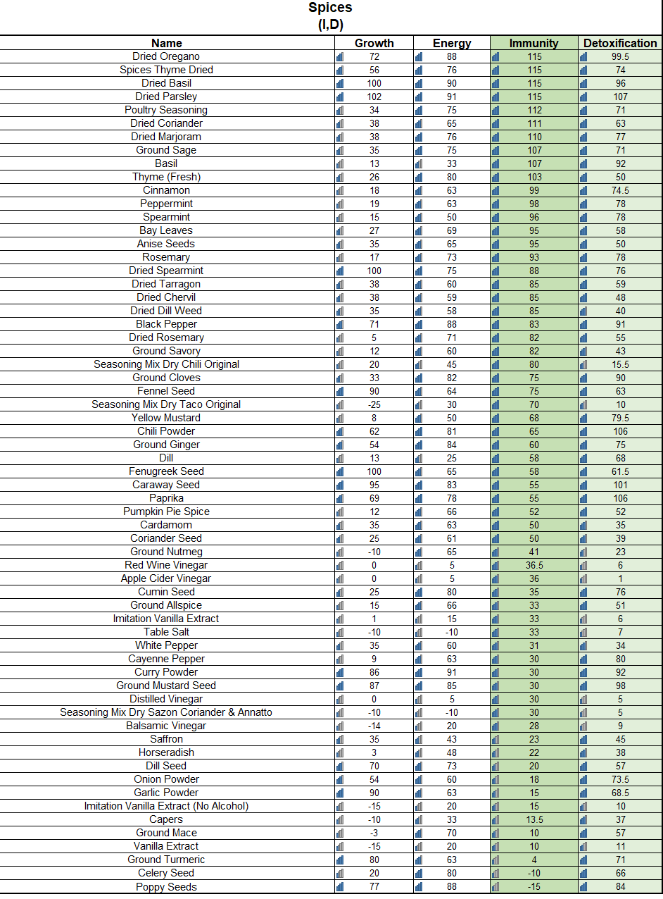

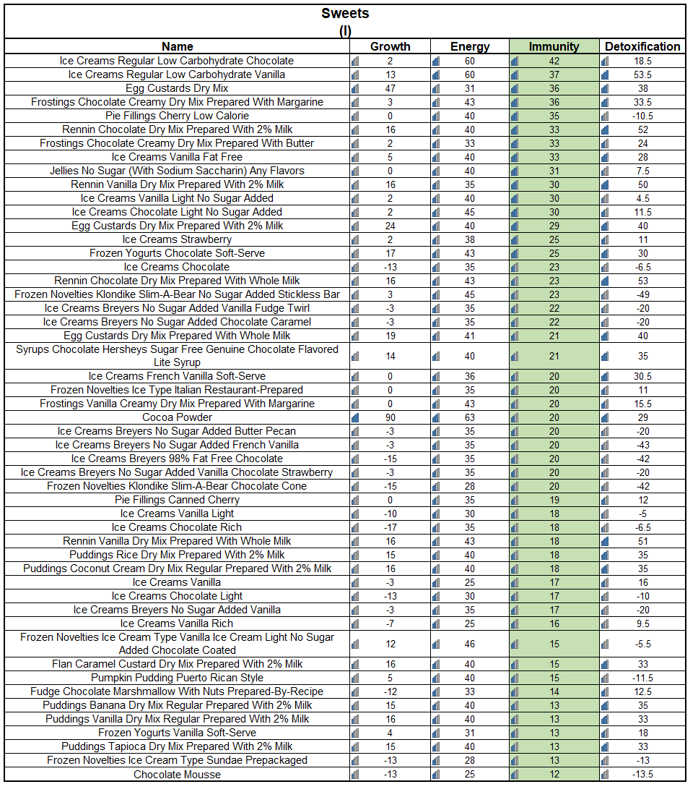

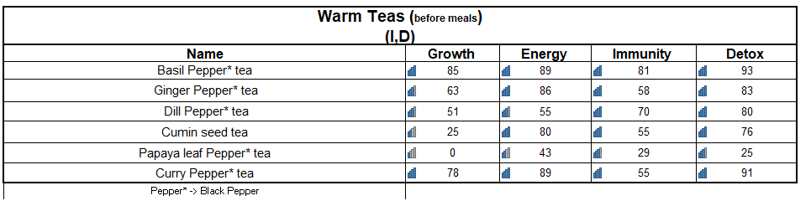

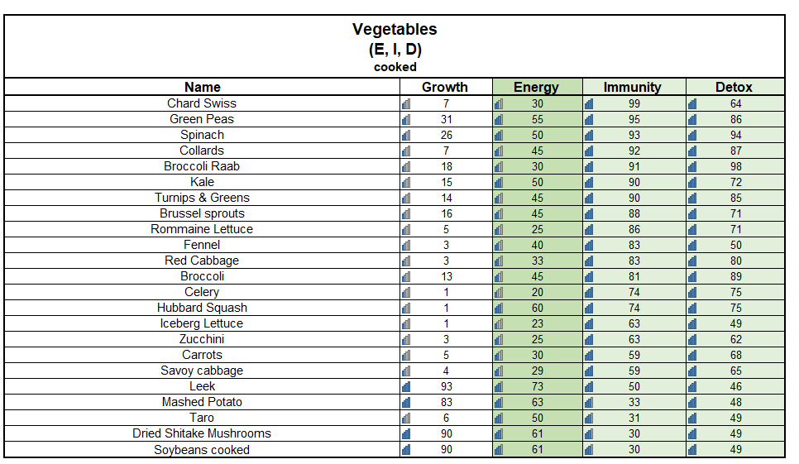

## Section-6 Conclusion:

I’m greatly thankful to Meals on Wheels organization to giving me access and allowing me to work on this project. I would like to highlight a few key learnings that came out of this exercise.

1. The first important one is that food needs to be and can be measured in terms of 4 dimensions – Growth, Energy, Immunity, and Detoxification.
2. In understanding the scores along the four dimensions, i have recommended improvements mostly around Immunity and Detoxification
3. The improvements are made on only the side orders while keeping the main dish as is
4. I have added a section of different food items that have been prioritized using the FOGO algorithm (patent in process)
5. The objective of the improvements are tailored to the elderly audience that Meals on Wheels program services.

I’m excited and eagerly looking forward to work even more closer with Meals on Wheels program to make an already great service to even greater and more complete.